LAB ASSIGNMENT-9



NAME: M Gyanada Chowdary

REG.NO: 21bce7727

COURSE: Computer Networks

SLOT: L21+22

TASK:

create and configure a network and analyse TCP and UDP packets in simulation mode.

Step 1:

Create a network using One server and 4 PC’s

Configure their IP Addresses

DNS – 192.168.11.5

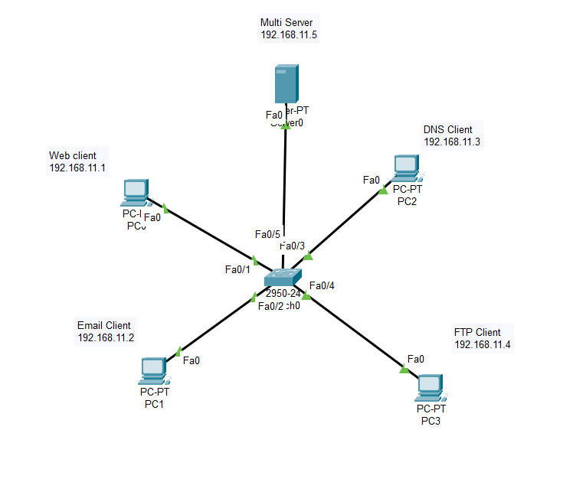

Step 2:

Go to Server🡪DNS🡪 Switch on

Add a domain

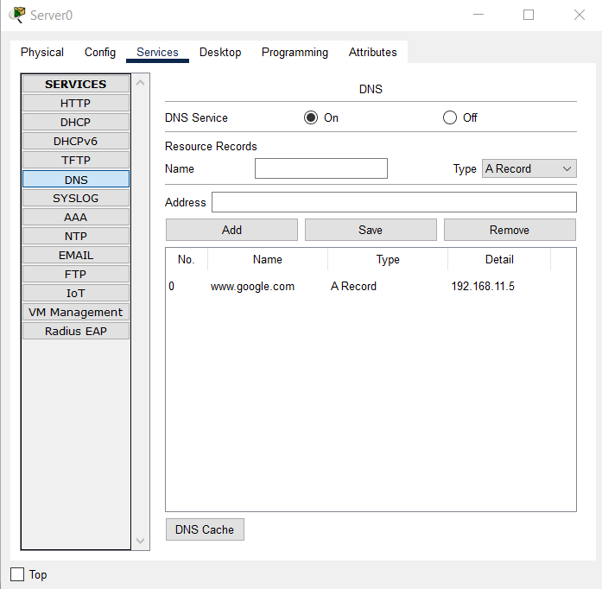

Step 3:

Go to HTTP🡪 Switch on both HHTPS and HTTP 🡪Index.html🡪edit

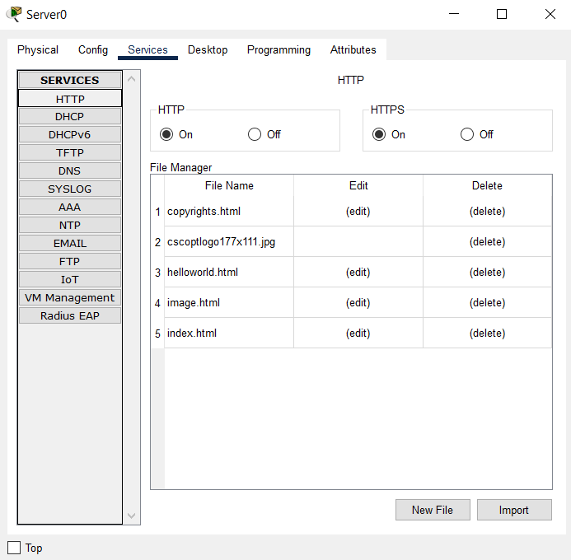

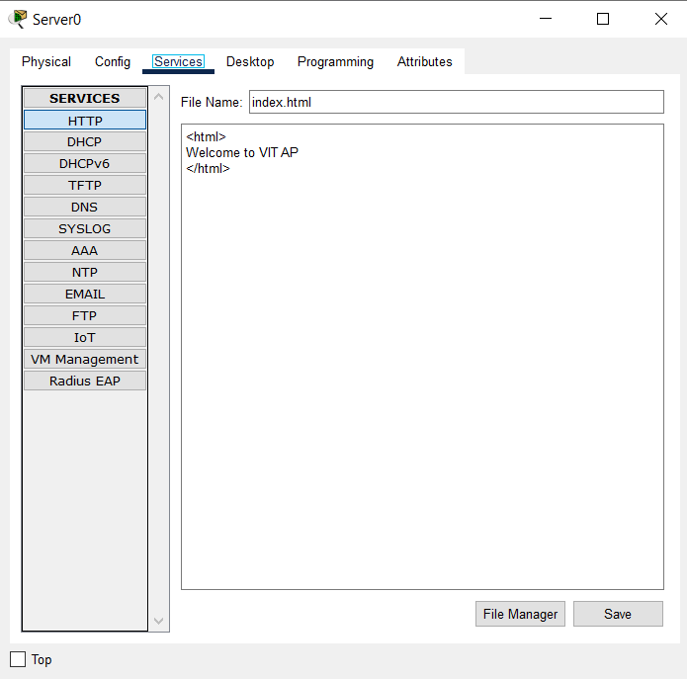

Step 4:

Check if Server is able to connect

Go to Server🡪Desktop🡪command prompt

PC> nslook [www.google.com](http://www.google.com)

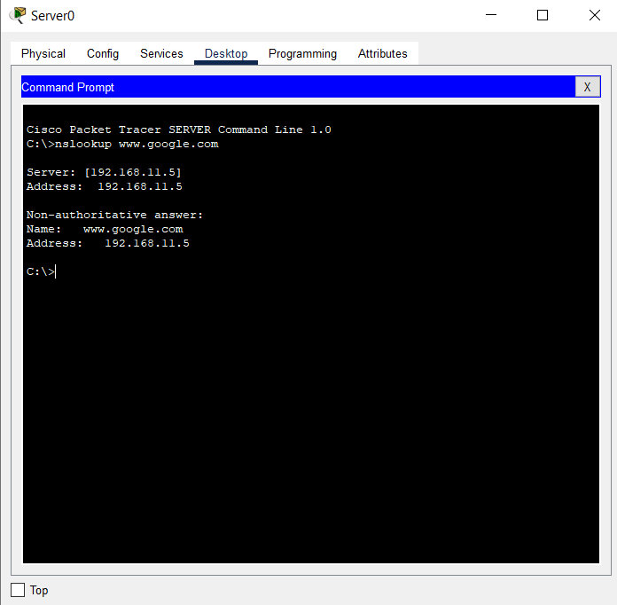

Go to server🡪Desktop🡪Web browser

Type URL – 192.168.11.5

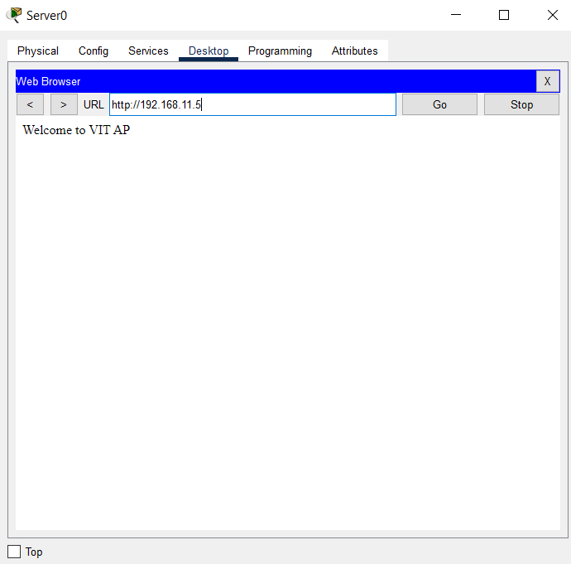

Step 5:

Go to PC0(Web Client)🡪 desktop🡪 Email🡪 configure Email

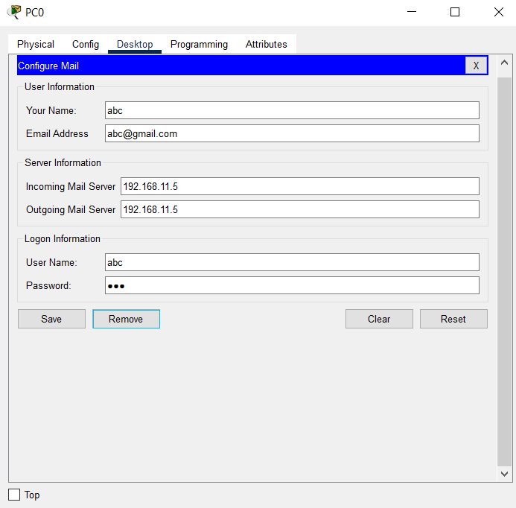

Go to Pc1(Email Client)🡪desktop🡪Email🡪configure email

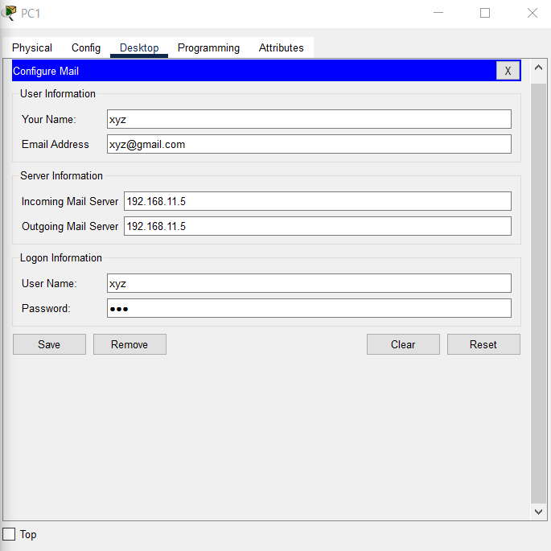

Step 6:

Go to Server🡪Services🡪Email🡪Switch on both SMTP and POP3

Domain name: gmail.com

Add users

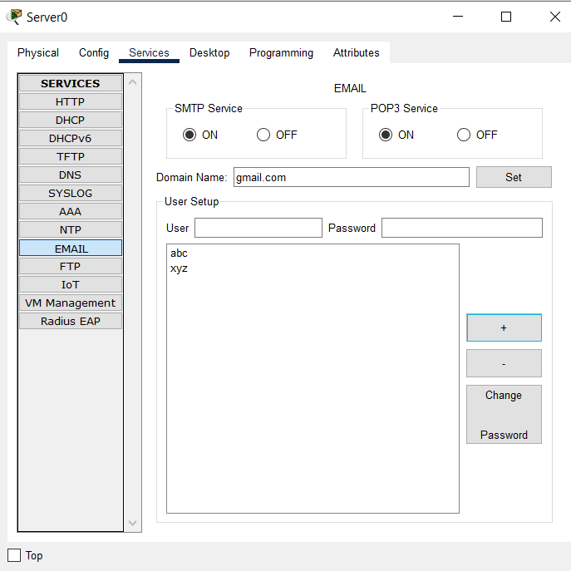

Step 7:

Send mail from PC0 to PC 1

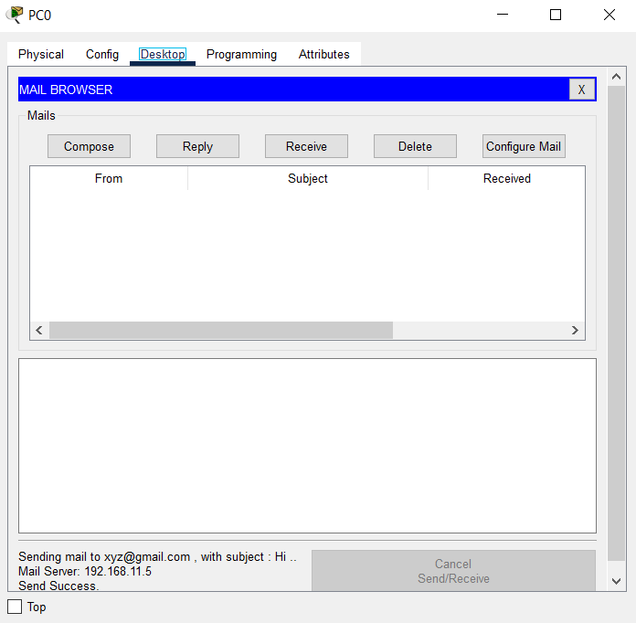

Receive mail from PC0

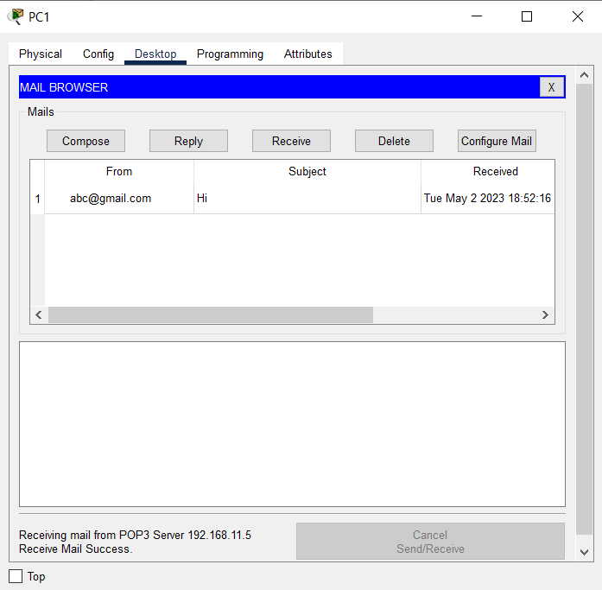

Send Email from PC1 to PC0

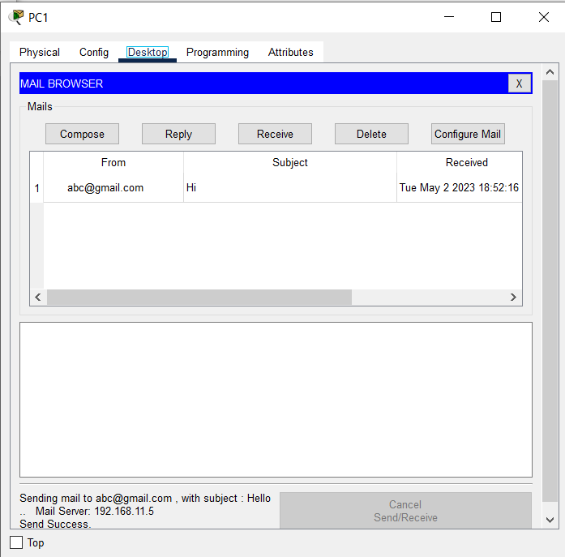

Receive Email from PC 1

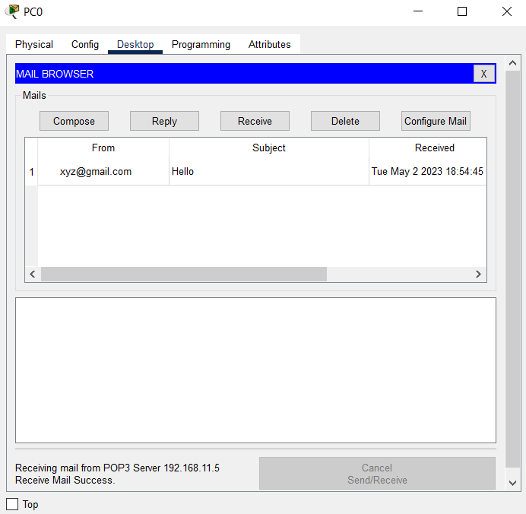

Step 8:

**FTP Client:**

Go to Server🡪 FTP-🡪 add user with all features

WRDNL

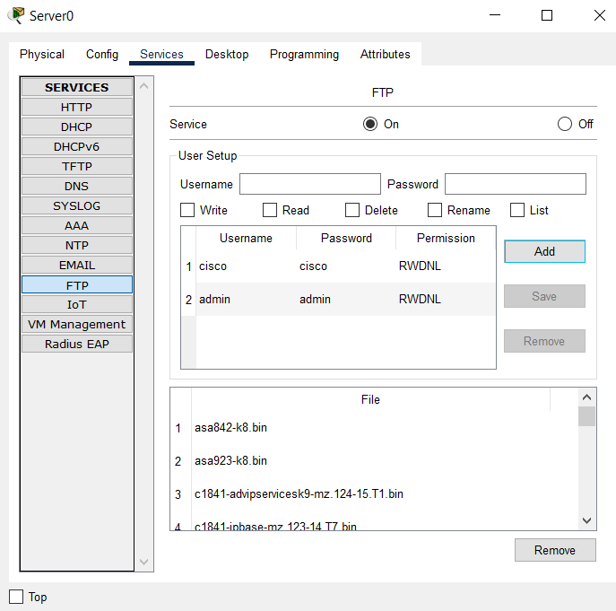

Step 9:

Go to Server🡪Command Prompt🡪

ftp [www.google.com](http://www.google.com)

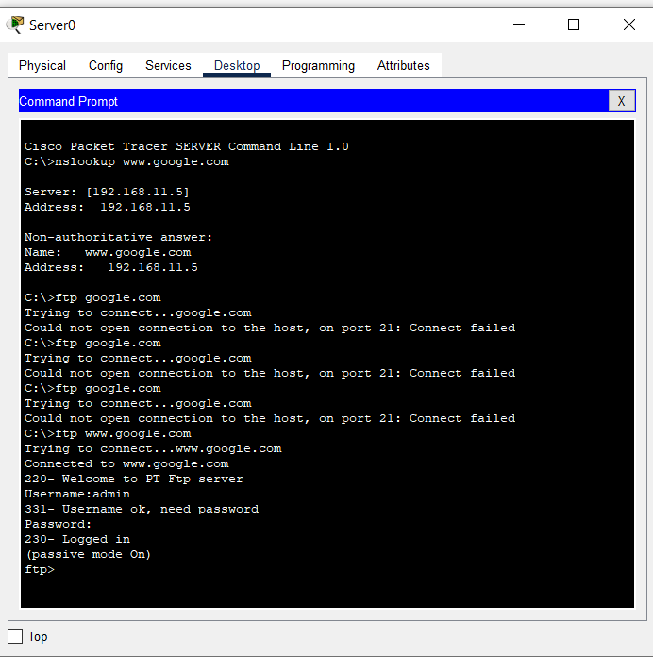

Step 10:

Go to Server🡪 text editor🡪 create a file

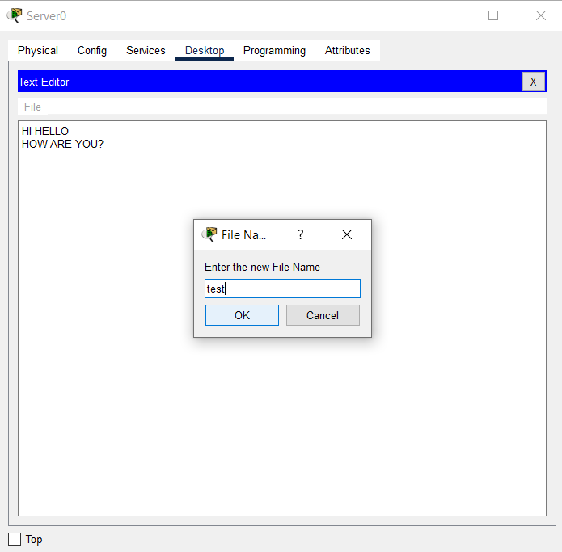

Put test.txt

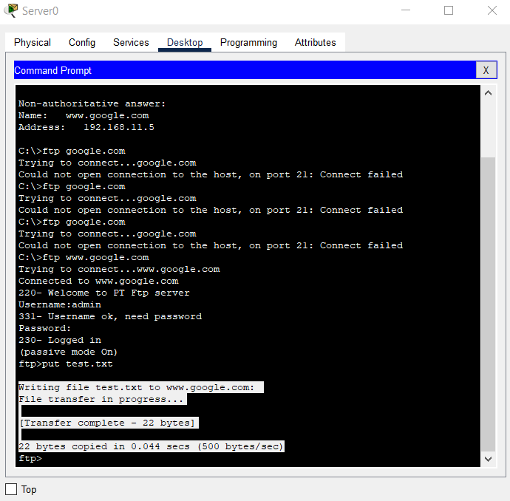

ftp> dir

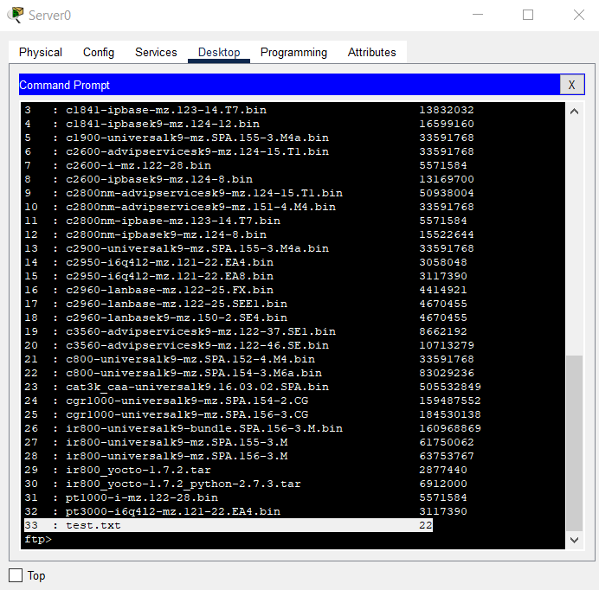

The above process is called “uploading the file”

Step 11:

Downloading the file:

Go to DNS client🡪command prompt🡪

ftp [www.google.com](http://www.google.com)

give username and password

ftp> get test.txt

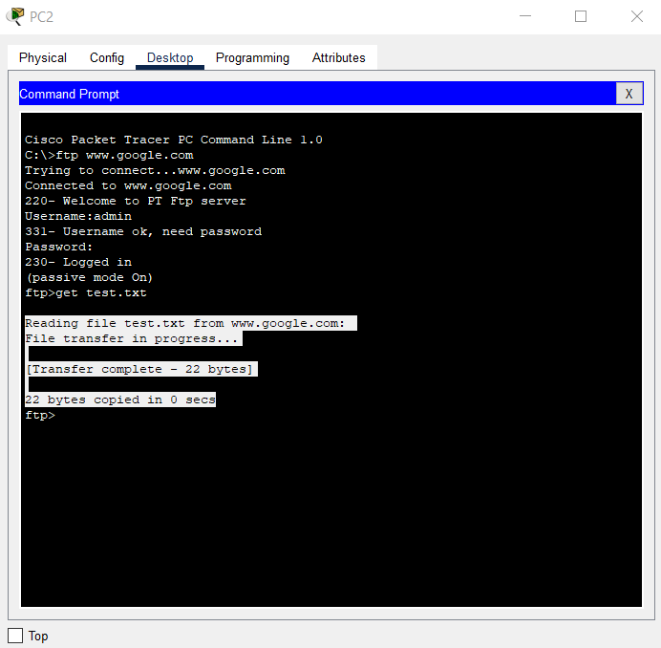

Get file to DNS server

ftp>dir

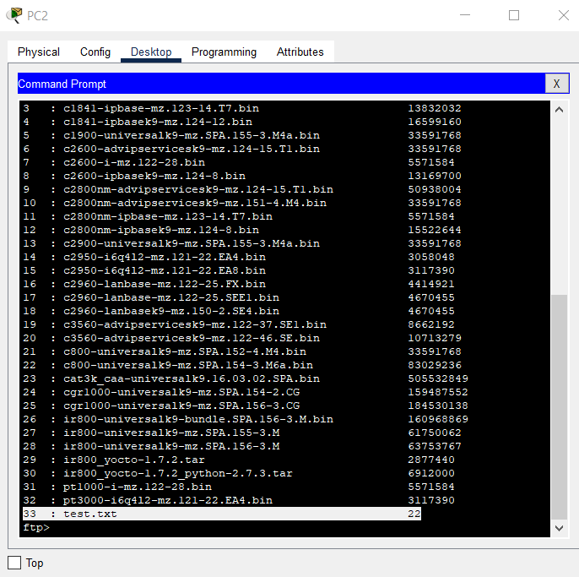

Step 12:

Simulation:

